**SSO IS Data elements for Acute Leukemia**

Table of Contents

**Appendix - 12.3**: Facility Numbers 7

**Appendix - 12.11**: Valid 2-digits Postal Codes 8

**Appendix - 12.12**: SCT Disease Indication Classification 9

**Appendix - 12.13**: MOHLTC Master Numbering System 10

**Data Elements for Acute Leukemia**

| **#** | **Entity** | **Data Element** | **COLUMN_NAME** | **Definition (Description)** | **Format** | **Valid values(Notes)** | **Applies to** | **Purpose and Use** | **Mandatory** | **Business key (Uniqueness)** |
| --- | --- | --- | --- | --- | --- | --- | --- | --- | --- | --- |
| 1 | Leukemia | Health Card Number | Health_Card_Number | Patient's Ontario Health Card Number. | CHAR(10) | Valid values: 0-unknown, 1-out of country (OOC), or valid HCN | All | To link data with other CCO data holding areas. | Yes |  |
| 2 | Leukemia | Patient’s Chart Number | Patient_Chart_Number | Facilities internal unique patient identifier. | CHAR (12) | Must be alpha-numeric (i.e. no punctuation, must have numbers and characters). | All | For reimbursement: to uniquely identify procedure for a patient;  For investigations: chart number will be provided in log file for the records with errors. This will allow facilities to link data in log file with their data sets. | Yes | Yes |
| 3 | Leukemia | Date of Birth | Date_Of_Birth | Patient birth date | CHAR (8) YYYYMMDD | Valid date | All | To link data with other CCO data holding areas. | Yes |  |
| 4 | Leukemia | Postal Code | Postal_Code | Patient’s residential postal code. | CHAR(10) | 1. Must match any of these format masks: ANANAN, NNNNN, NNNNN-NNNN, AA  2. If matches mask ANANAN, then can’t begin with D,F,I,O,Q,U, or W  3. If matches mask of AA, then should match any entry listed in  [**Appendix - 12.11**](https://www.cancercare.on.ca/ext/databook/db1213/Appendix/Appendix_1-6_-_Province_and_State_codes.htm) (Province and State Codes). | All | For geographical distribution reporting. | Yes |  |
| 5 | Leukemia | Facility Number | facility_number | Submitting facility number | CHAR(3) | Valid facility number MOHLTC classification listed in **Appendix - 12.3** | All | For funding and planning | Yes | Yes |
| 6 | Leukemia | Type of leukemia | type_of_leukemia | Type of Leukemia such as AML/ALL | CHAR(3) | Valid codes listed in **Appendix - 12.12** | All |  | Yes |  |
| 7 | Leukemia | Date of Admission | Admit_date | Date patient admitted to the hospital | CHAR(8) YYYYMMDD | Valid date or null | All | For reimbursement: to calculate length of hospital stay (not ICU) | No |  |
| 8 | Leukemia | Discharge Date | Discharge_date | Hospital Discharge Date | CHAR(8) YYYYMMDD | Valid date or null | All | For reimbursement: to calculate length of hospital stay (not ICU) | No |  |
| 9 | Leukemia | Admission ongoing Flag | Admission_ongoing_flag | Hospital Admission flag | CHAR (3) | Valid values :“Yes” or “No” or null | All | To understand if a patient admitted in one quarter continues into another quarter | No |  |
| 10 | Leukemia | ICU admit date | icu_admit_date | Date patient got admitted to ICU | CHAR(8) YYYYMMDD | Valid date. | All | For reimbursement: to calculate length of ICU stay. | No |  |
| 11 | Leukemia | ICU admit time | icu_admit_time | Time patient was admitted to ICU | HHMM | 0000 (midnight) to 2359, as per CIHI NACRS format. | All | For reimbursement: to calculate length of ICU stay. | No |  |
| 12 | Leukemia | ICU discharge date | icu_discharge_date | Date patient was discharged from ICU | CHAR(8) YYYYMMDD | Valid date could be the same or greater than icu_admit_date | All | For reimbursement: to calculate length of ICU stay. | No |  |
| 13 | Leukemia | ICU discharge time | icu_discharge_time | Time patient was discharged from ICU | HHMM | 0000 (midnight) to 2359, as per CIHI NACRS format. | All | For reimbursement: to calculate length of ICU stay. | No |  |
| 14 | Leukemia | ICU ongoing flag | ICU_ongoing_flag | ICU ongoing flag | CHAR(3) | Valid values “Yes” or “No” | All | To understand whether the ICU admission is ongoing/not in that quarter | No |  |
| 15 | Leukemia | Visit type | visit_type | Type of the visit | CHAR(15) | Valid values for visit type are: Regional outreach or/ Urgent care clinic | All | For reimbursement: to uniquely identify the visit type of a patient | No |  |
| 16 | Leukemia | Visit date | visit_date | Date of visit | CHAR(8) YYYYMMDD | Valid date and must be within submitting quarter and year. | All | Planning funding volumes and capacity management | No | Yes |
| 17 | Leukemia | Share Care Facility | Share_Care_faciity | Name of the facility that patients care is shared with | CHAR(3) | Valid facility number as per classification **Appendix - 12.13** | All | Planning funding volumes and capacity management | No |  |
| 18 | Leukemia | Date Receipt Referral | Date_receipt_referral | Date patient was referred for consultation with hematologist | CHAR(8) YYYYMMDD | Must be on or before date of first consult and first induction. | All | Performance metrics – wait times | No |  |
| 19 | Leukemia | Date Patient First Consult | Date_patient_first_consult | Date of first consultation with hematologist (C1S) | CHAR(8) YYYYMMDD | Must be on or after date of referral and on or before date of first induction. | All | Performance metrics – wait times | No |  |
| 20 | Leukemia | Date of first induction | Date_of_first_induction | Date of first induction treatment | CHAR(8) YYYYMMDD | Must be on or after date of referral and date of first consult. | All | Performance metrics – wait times | No |  |
| 21 | Leukemia | Date of relapse | Date_of_relapse | Date of relapse diagnosis | CHAR(8) YYYYMMDD | Must be a valid date | All | For reimbursement | No |  |
| 22 | Leukemia | Reason for Admission | Reason_for_admission | Reason for admission in to hospital | Character (drop down)  Options: Induction,  Consolidation  Intensification  Febrile Neutropenia  Other | Must select drop down option | All | For reimbursement | No | No |

**Appendix - 12.3: Facility Numbers**

|  |  |  |  |
| --- | --- | --- | --- |
| **#** | **Program Title** | **Submitting Hospital** | **Facility Number** |
| 1 | Stem Cell Transplant | Hamilton Health Sciences Corporation | 942 |
| Kingston General Hospital | 693 |
| London Health Sciences | 936 |
| Sudbury Regional Hospital | 959 |
| The Ottawa Hospital | 958 |
| University Health Network | 947 |
| Trillium Health Partners | 975 |
| 2 | a) Sarcoma (Chemotherapy)  b) Sarcoma (Pathology)  c) Sarcoma (Prosthesis) | The Ottawa Hospital | 958 |
| Mt. Sinai Hospital | 842 |
| Hamilton Health Sciences Corporation | 942 |
| London Health Sciences | 936 |
| University Health Network | 947 |
| Kingston General Hospital | 693 |
| Lakeridge | 952 |
| Royal Victoria Regional Health Center | 606 |
| Grand River Health Corporation | 930 |
| Windsor Regional Center | 933 |
| 3 | Acute Leukemia | University Health Network | 947 |
| Lakeridge | 952 |
| Southlake | 736 |
| Credit Valley and Trillium | 975 |
| Sunnybrook | 953 |
| Royal Victoria Regional Health Center | 606 |
| Mt Sinai Hospital | 842 |
| 4 | Neuroendocrine | University Health Network | 947 |
| Sunnybrook Health Sciences Centre | 953 |
| London Health Sciences | 936 |

**Appendix - 12.11: Valid 2-digits Postal Codes**

(Source: Cancer Care Ontario's Data Book - 2014-2015 - Appendix B - Province and State codes, at link <http://www.cancercare.on.ca/ext/databook/db1415/Appendix/Appendix_1-6_-_Province_and_State_codes.htm> )

The table below provides list of valid 2 digit postal codes for province and State codes.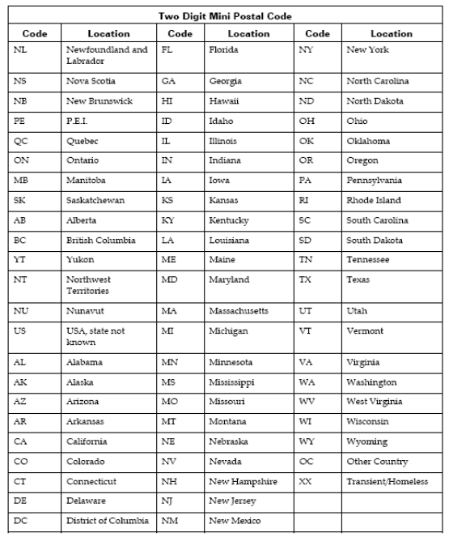

**Appendix - 12.12: SCT Disease Indication Classification**

(Source: Cancer Care Ontario's Data Book - 2012-2013, Appendix 12.1 - SCT Disease Indication Classification, at link <https://www.cancercare.on.ca/ext/databook/db1213/databook.htm> ).

|  |  |
| --- | --- |
| **Name** | **Description** |
| AML /APL | Acute Myeloid Leukemia (including Acute promyelocytic leukemia (APL)) |
| ALL | Acute Lymphoblastic Leukemia  (including lymphoblastic lymphoma) |
| AcuteLeukemiaOther | Acute leukemia other |
| CML | Chronic Myeloid Leukemia |
| CLL | Chronic Lymphocytic Leukemia |
| MDS/MPD | Myelodysplastic / Myeloproliferative Disease |
| MM | Multiple Myeloma |
| Amyloidosis | Amyloidosis |
| NHL | Non-Hodgkin's Lymphoma |
| HL | Hodgkin's Lymphoma |
| SAA | Severe aplastic anemia |
| Solid-Sarcoma | Solid tumours - Sarcoma |
| Solid-GermCell | Solid tumours - Germ cell tumours |
| Solid-Other | Solid tumours - Other |
| Other | Transplant indication not listed above |

**Appendix - 12.13: MOHLTC Master Numbering System**

The Master Numbering System has been developed for the purpose of bringing together all Health Facilities and Programs under one system of identification. The list is a composite of health and health related units, facilities, clinics, programs and services. Each such organization has been assigned a unique four digit identifying code.

(Source: Cancer Care Ontario's Data Book - 2014-2015 - Appendix-A -MOHLTC Master Numbering System at link <http://www.cancercare.on.ca/ext/databook/db1415/documents/Appendix/CCO_DBK_Appendix_A_APR_14.pdf> )